Day 14 May 13:
Fluent API:
Partial Classes:
TPH: Table,
Desc
Package manager console

Day 15 May 14:
Code First Approach, Database First Approach
EFCore with stored procedure
Dapper ORM, ORMs types

This Week Agenda
WebAPI, features, connection, exception, communication,authentication and auth
Optimizations, validation, json ,

Capstone Project
Level 1: AI can use for UI purpose., capstone project
Level 2: Exchange of Project and add on features
Level 3: Migration Project

Day 18 May 19
Frontend(Angular)
Frontend can understand JSON, HTML, Text;

Day 19 May 20
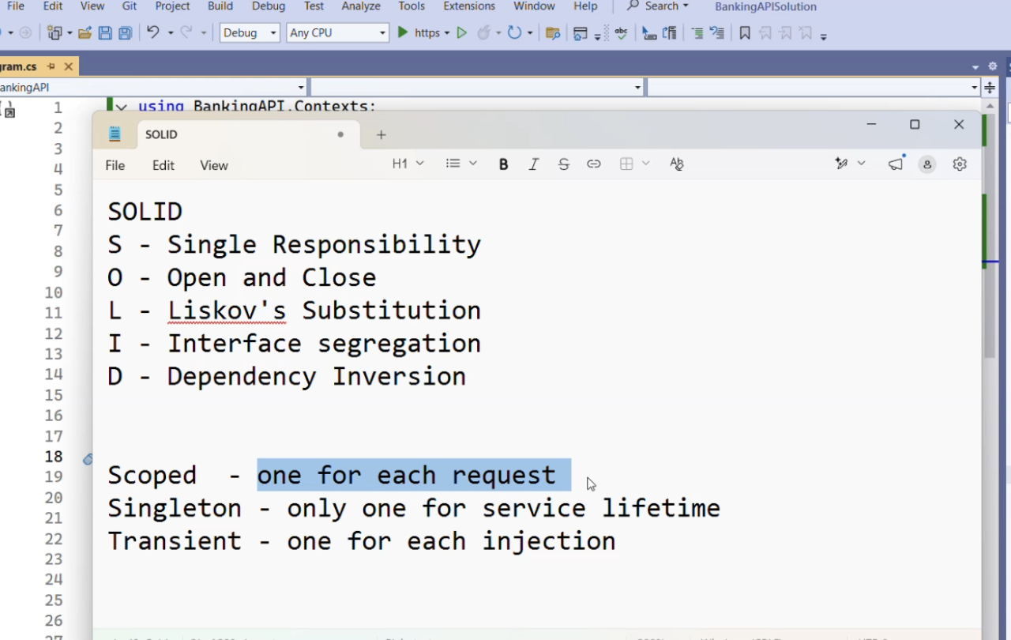
Dependency Injection
Scope, transit,
DTO

Day 20 May 21
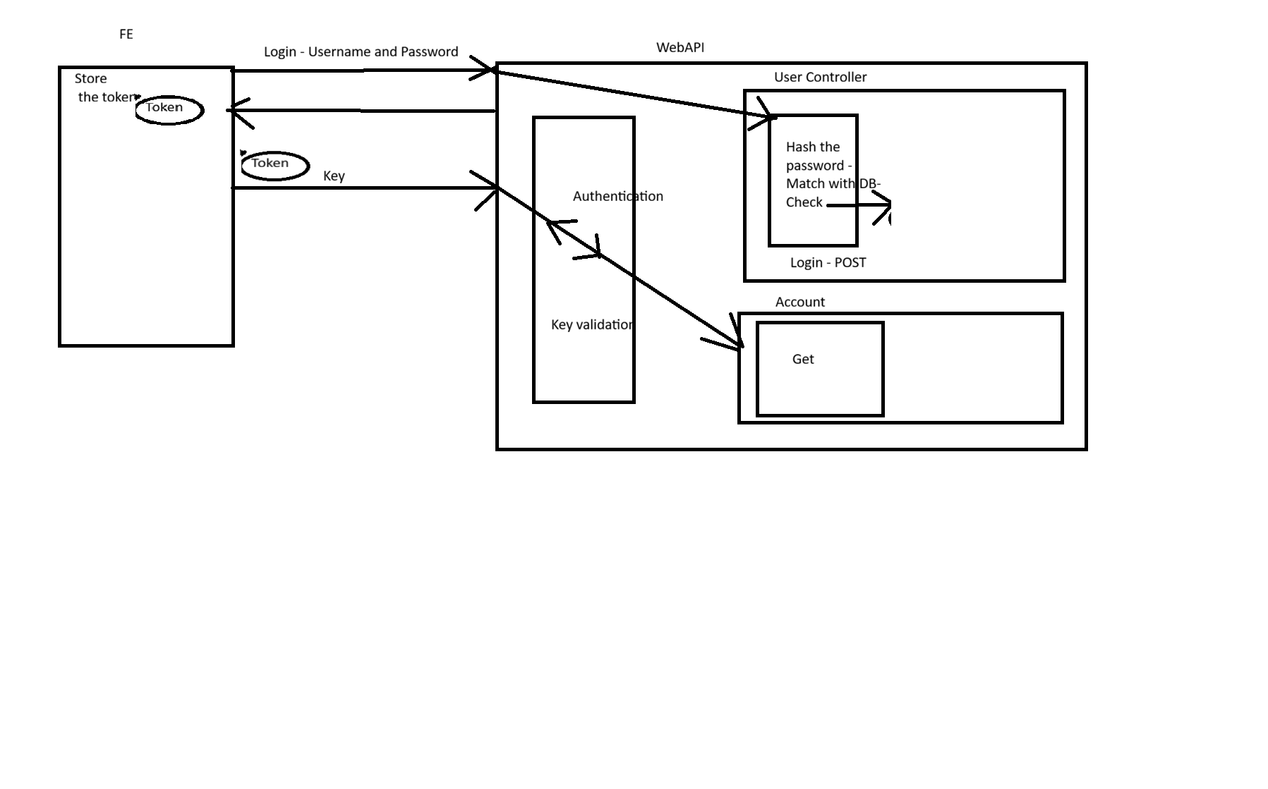

Project Link:
https://drive.google.com/file/d/1LX0mzpRl_HG6w9eBnq0XkQ8xgCCqH8_K/view

Capstone Project Title | Students
Hospital Appointment & Patient Management System | Affan Waseem Ahammed Mulla, Preetam Tony J
Smart Inventory & Warehouse Management | Akshaya K S, Raghav Arora
HRMS & Employee Lifecycle Management | Ananya Ganapati Hegde, RENU AAYUSH MADDI
Real Estate Property & Rental Platform | Arvind Vikram M S, Sabareesh T
Online Examination & Assessment Platform | Aswin M A, Sai Nikitha NSR
Restaurant Order & Kitchen Management | Kokkula Bhargav, Sarveswaran B
Insurance Claim Processing System | Davish E, Seema maglin S
Logistics & Shipment Tracking System | Dhanush Keloth, Shethu ram M R
E-Commerce Marketplace Platform | Dharshini K, Siva Kavindra T
School ERP Management System | Hareshwaran S, Sivaprakash S
Travel & Tour Package Management | Iniyan C M, Sivasabari P
Event Management & Ticketing Platform | KeerthiKeswaran K S, Sri Manikandan R
Fleet & Vehicle Maintenance System | Krishna Ketan Varia, Sushan Rai
Complaint & Grievance Redressal Portal | Laxman P, C Teenu Deekshith
Manufacturing Production Monitoring System | Mohamed Abubakkar S, Vaibhav Gupta
Learning Management System (LMS) | Nandhiraja K, Vigneshwaran B
Hotel & Resort Operations Management | Nipun Sharma, Vijay D V
Agriculture & Farm Monitoring Platform | Padmavathi SJ
Digital Document Approval Workflow System | Pratik Sarangi
Smart Society / Apartment Management System | Preetam Sasisekhara Kommavarapu

Authentication & Password Security
- Passwords should be stored using hashing, not encryption, since hashing is one-way and cannot be reversed.
- A unique salt/hash key is generated for each user and stored along with the hashed password.
- During login, the stored salt is used to hash the entered password and compare it with the stored hash.
- Identical passwords produce different hashes due to salting.
- Passwords can be:
  - User-defined
  - Auto-generated and emailed
  - Set through a password reset link

User Registration
- Registration collects customer information such as:
  - Name
  - Email
  - Phone Number
  - Date of Birth
- Customer ID and status are auto-generated.
- User and Customer records are created together within a transaction to maintain data integrity.
- User and Customer entities have a one-to-one relationship.
- Username serves as the unique login identifier.

Authentication Methods

Local Authentication
- Users register and log in using credentials stored in the application database.
- Login validates credentials and generates an authentication token.

Third-Party Authentication (OAuth)
- Users can authenticate through providers such as Google or Microsoft.
- Users control which information (email, name, phone, etc.) is shared.
- Applications receive a unique provider-issued identifier and selected profile data.
- Login via external providers and local login are separate authentication flows.

Token-Based Authentication
- REST APIs are stateless and use tokens to identify authenticated users.
- After successful login:
  - Credentials are validated
  - A token is generated
  - The token is returned to the client
- Tokens are sent with subsequent requests to access protected resources.

JWT (JSON Web Token)

JWT Structure
A JWT contains:
- Header
- Payload (Claims)
- Signature

Claims
Typical claims include:
- Username
- Name
- Role
- Unique Identifier

Security
- The secret key is used to sign the token.
- The secret key is not visible inside the token.
- Token validation verifies that the token was issued by a trusted source.

Refresh Tokens
- Refresh tokens extend session validity without requiring frequent logins.
- They contain minimal information compared to the main access token.
- Refreshing tokens indefinitely is not recommended; periodic re-authentication is required.

Token Storage & Security
Common storage options:
- Local Storage
- Session Storage
- Cookies
- Secure Vaults
Considerations:
- Session storage and vaults provide stronger security.
- Only minimal user information should be stored on the client side.
- On logout, both access and refresh tokens should be removed.

Login Workflow
- User submits username and password.
- Password is hashed using the stored salt/key.
- Hashed value is compared with the stored hash.
- If valid:
  - User information is retrieved.
  - JWT token is generated.
  - Token is returned to the client.
- If invalid:
  - Authentication fails with an invalid credential error.

JWT Authentication Implementation

Token Generation
- Uses:
  - Secret Key
  - Issuer
  - Expiration Time
- Claims are added to the payload.
- Token is signed using a secure hashing algorithm.

Authentication Configuration
- JWT is configured as the default authentication scheme.
- Token validation includes:
  - Issuer validation
  - Signing key validation
  - Lifetime validation
- Authentication middleware must execute before authorization middleware.

Authorization
- Protected endpoints require a valid JWT token.
- Tokens are typically supplied in the Authorization header.
- Missing or invalid tokens result in unauthorized responses.

HTTP Status Codes
- 401 Unauthorized → User is not authenticated.
- 403 Forbidden → User is authenticated but lacks required permissions.

Dependency Injection & Service Design
- Reviewed .NET dependency injection lifetimes:
  - Scoped
  - Singleton
  - Transient
- Services and repositories are injected through constructors.
- Authentication functionality is handled through dedicated service and controller layers.

Repository & Database Design
- Removed repetitive repository code by replacing abstract implementations with a reusable base/general class.
- User table stores authentication information.
- Customer table stores profile and contact information.
- One-to-one mapping is maintained between User and Customer entities.

JWT Authentication Testing & Troubleshooting
- JWT tokens can be tested using Postman and Swagger.
- Common issues include:
  - Invalid issuer
  - Incorrect signing key
  - Token expiration
  - Configuration mismatches
- Expired tokens require re-authentication unless refresh tokens are implemented.

Token Security Best Practices
- Store secret keys securely (e.g., Azure Key Vault).
- Generate strong random secret keys.
- Validate token issuer, signature, and expiration.
- Avoid exposing sensitive information in token payloads.

Overall Summary
The session focused on implementing a complete authentication system, covering password hashing and salting, user registration, OAuth concepts, JWT token generation and validation, token storage strategies, authentication workflows, authorization setup, dependency injection, repository design, and security best practices for enterprise applications.

Day 21 May 22

Topics planned for next week
- Filters and Pipes in Web API
- Deployment of the application
- Possibly starting the Frontend
- SignalR for two-way real-time communication
- Mapping / AutoMapper
- Miscellaneous tools required in real applications
- Dynamic Endpoints
  - Different responses based on parameters

Important instruction
- Start seriously working on your Web API project now.
- There will be an evaluation/viva for the backend project.
- You’ll need to:
  - Share your project
  - Explain what you implemented
  - Explain why you implemented it that way

Capstone timeline
- Continue working on the capstone project in parallel
- Deliver the backend by the following week
- Then the class will move toward frontend integration

Architecture & Design Decisions
- Compared Monolith and Microservice architectures.
- Architecture selection should be based on:
  - Team expertise
  - Project requirements
  - System scale and complexity
- Microservices provide scalability and independent deployment but add operational complexity.
- Monoliths are often preferred when simplicity, faster development, and easier maintenance are priorities.
- Tight project timelines and customer demands can heavily influence architecture choices.

Deployment & Scalability
- High-traffic services can be deployed independently as separate Kubernetes pods.
- This enables:
  - Better resource utilization
  - Independent scaling
  - Reduced infrastructure costs

User Roles & Authorization
- Users can possess multiple roles simultaneously (e.g., owner and tenant).
- Role-Based Authorization (RBAC) is suitable for systems with fixed roles.
- Policy-Based Authorization is recommended for enterprise applications requiring complex permission rules and fine-grained access control.

API Security & Endpoint Design
- Account-related information should be accessible only to authenticated users.
- Sensitive data such as account numbers should be passed through request DTOs rather than URL parameters.
- JWT authentication is used to secure transaction-related endpoints.

Transaction Management
- Every transaction must be recorded, including both successful and failed attempts.
- Transaction handling should support:
  - Account validation
  - Balance verification
  - Savepoints and rollback mechanisms
  - Failure logging for audit purposes

Transaction Service Features
Implemented core transaction operations:
- Deposit
- Withdrawal
- Transfer
Key capabilities:
- Balance updates
- Success and failure logging
- Account validity checks
- Minimum balance validation
- Error handling with rollback support

Data Models & DTOs

Transaction Model
- Added an Amount field.
- Updated repositories to support transaction operations.

Request DTOs
Created dedicated DTOs for:
- Deposit requests
- Withdrawal requests
- Transfer requests

Response DTO
Transaction responses contain:
- Reference number
- Transaction date
- Source account
- Destination account
- Amount
- Transaction status

Transaction Retrieval & Reporting

Sorting
- Transactions are displayed in descending order of transaction date (latest first).

Filtering & Pagination
Support added for:
- Date-range filtering
- Amount-range filtering
- Dynamic sorting
- Pagination for large datasets

Day 22 May 25
Policy-based authorization in ASP.NET Core | Microsoft Learn

Pagination

1. Architecture Discussion
- Differences between Monolith and Microservice architectures were discussed.
- Microservices provide scalability and independent deployment but introduce communication and coordination complexity.
- Monoliths offer simpler development, deployment, and maintenance for many projects.
- Architecture choice should depend on:
  - Team expertise
  - Customer requirements
  - Project size and complexity
- A poorly implemented microservice architecture can perform worse than a monolith.

2. Industry Trends & Project Constraints
- Industry preference has shifted toward monoliths in many cases due to the complexity of managing microservices.
- Customer requirements and strict deadlines significantly influence architecture decisions.
- High-pressure environments often make flawless microservice implementation difficult.

3. Kubernetes & Deployment Strategy
- High-traffic services can be deployed as separate Kubernetes pods.
- This approach:
  - Optimizes resource utilization
  - Enables independent scaling
  - Reduces infrastructure costs

4. User Roles & Authorization

User Roles
- A single user can have multiple roles simultaneously (e.g., Property Owner and Tenant).

Authorization Approaches
Role-Based Authorization (RBAC)
- Suitable for systems with fixed roles and permissions.
- Easier to implement and maintain.
Policy-Based Authorization
- Recommended for enterprise applications with complex business rules.
- Supports fine-grained access control beyond predefined roles.

5. Endpoint Design & Security
- Account details and account statements should be accessible only to authenticated users.
- Sensitive information (e.g., account numbers) should:
  - Be passed through DTOs in the request body.
  - Not be exposed through URL parameters.
- JWT-based authorization was implemented for securing transaction endpoints.

6. Transaction Management

Transaction Recording
- Every transaction must be recorded, including:
  - Successful transactions
  - Failed transactions

Error Handling
- Savepoints and rollback mechanisms should be used to maintain consistency.
- Failed transactions should still be logged with an appropriate status.

Validation Checks
- Verify account existence.
- Check sufficient balance before withdrawals/transfers.
- Handle transaction failures gracefully.

7. Transaction Service Implementation
Implemented transaction operations:
- Deposit
- Withdrawal
- Transfer
Key features:
- Logs both successful and failed transactions.
- Updates account balances.
- Performs account validation.
- Enforces minimum balance rules.
- Uses rollback mechanisms during errors.
- Secures endpoints using JWT authentication.

8. Transaction Model & DTO Design

Transaction Model Updates
- Added an Amount attribute.
- Updated repositories to support transaction operations.

Request DTOs
Created separate DTOs for:
- Deposit Requests
- Withdrawal Requests
- Transfer Requests

Response DTO
Transaction response includes:
- Reference Number
- Transaction Date
- Source Account
- Destination Account
- Amount
- Transaction Status

9. Transaction Data Retrieval

Sorting
- Transactions should be sorted by transaction date in descending order.
- Most recent transactions appear first.

Filtering & Pagination
Implemented dynamic filtering based on:
- Date Range
- Amount Range
Additional features:
- Sorting options
- Pagination support for large datasets

Day 23 May 26
Async await
Unit Testing

1. Asynchronous Programming Concepts

Why Async is Needed
- Enables non-blocking execution when tasks depend on external operations (database, APIs, etc.).
- Improves application responsiveness and performance.

Evolution of Async Programming
- Started with manual thread creation and management.
- Moved to Thread Pool management.
- Modern .NET uses async/await, simplifying asynchronous execution.

Async/Await Mechanism
- async allows a method to run asynchronously.
- Task<T> represents an operation that will complete later.
- await pauses execution until the task completes while freeing the thread to execute other work.
- While a task is waiting, the processor can execute other ready tasks.

When to Use Async
Use async when:
- Calling another async method.
- Performing heavy operations.
- Waiting for database/API responses.
Do not use async for:
- Simple mapping or lightweight methods.
- Methods without asynchronous dependencies.

Repository & Service Design
- Repository methods should return Task<T> for database operations.
- Token service does not require async implementation because it performs synchronous work.

2. Processor & Task Management

Multi-Task Execution
- Modern processors handle multiple tasks through rapid context switching.
- Hyperthreading improves processor utilization.
- Multiple tasks within a process reduce idle CPU time.

Scheduling
- Round Robin scheduling was discussed as an older approach and is generally not the primary scheduling mechanism in modern systems.

3. Async Controller Implementation

Changes Made
- Controller methods were converted to async.
- Performance improved without changing functionality.
- Transactions continued to work correctly after async implementation.

Important Clarification
- Object mapping methods do not need to be async unless they perform asynchronous work.

4. Unit Testing Fundamentals

Importance
- Detects bugs introduced by code changes.
- Prevents regressions.
- Verifies expected behavior.

Developer Responsibility
Developers should write:
- Unit Tests
- Integration Tests
Testing teams typically handle:
- Functional Testing
- System Testing
- Smoke Testing
- Regression Testing
- Stress Testing
- Load Testing
- Installation/Uninstallation Testing

5. Dependency Injection for Testing

Benefits
- Makes components easier to test.
- Allows replacement of real dependencies with mocks or test implementations.
- Supports injecting custom database contexts during tests.

6. Unit Test Project Setup

Frameworks
- NUnit
- xUnit
- MSTest

Best Practices
- Match test framework version with .NET version.
- Follow naming conventions for test classes.
- Use:
  - Setup methods → execute before each test.
  - Teardown methods → execute after each test.

7. Repository Testing

Database Testing
- Use Microsoft.EntityFrameworkCore.InMemory.
- Configure an in-memory database for isolated tests.

Test Cases Covered
- Add Customer
- Get Customer
- Update Customer
- Delete Customer

Validation Techniques
- Verify returned objects are not null.
- Validate auto-generated IDs.
- Compare expected and actual values.

8. Exception Testing

Importance
- Ensures proper error handling.
- Verifies expected exceptions are thrown.

Best Practices
- Test invalid scenarios.
- Use custom exception types when applicable.
- Validate specific exceptions rather than generic exceptions.

Example
- Deleting a non-existent customer should throw the expected custom exception.

9. Service Layer Testing

Dependency Injection
Inject:
- Repository objects
- Configuration objects
- Other dependencies

Token Service Testing
- Mock configuration values.
- Use in-memory key-value pairs to simulate application settings.

10. Mocking

Purpose
- Isolate the unit being tested.
- Avoid calling real dependencies.

Commonly Mocked Components
- Repositories
- Configuration
- External APIs
- Token services

Configuration Mocking
- Create in-memory dictionaries containing required configuration values.
- Add only necessary keys for the specific test scenario.

11. Unit Testing Process (AAA Pattern)

Arrange
- Prepare test data and dependencies.

Act
- Execute the method being tested.

Assert
- Verify the expected result.

Execution
- Run individual tests.
- Run all tests together.
- Compare expected vs actual outcomes.

12. Bugs Identified Through Unit Testing

Account Number Generation Issue
Problem:
- Exception occurred when no account numbers existed.
Solution:
- Logic was corrected to handle empty datasets properly.

Key Learning
- Unit testing helps uncover hidden logical defects before deployment.

13. Testing Guidelines

Coverage Recommendations
- Test normal scenarios.
- Test boundary conditions.
- Test exception/error scenarios.

Rule of Thumb
- Write at least 3 test cases per method:
  - Success case
  - Failure/invalid input case
  - Edge case

Day 24 May 27
Logging, Exception Automation

Application Logging

Importance
- Helps track errors, warnings, and application behavior.
- Useful for debugging and system monitoring.

Controller Logging
- Use Microsoft's built-in ILogger.
- Log invalid login attempts and exceptions.
- Include controller name and warning/error details.

Azure Monitoring
- Logs can be viewed and filtered through Azure Insights after deployment.

Business Audit Logging
- Track:
  - Table Name
  - Column Name
  - Old Value
  - New Value
  - Modified Date
  - Modified By

Log Archival
- Archive old logs periodically (e.g., monthly).
- Move old records to separate archive tables using scheduled jobs.

8. Serilog Implementation

Features
- File-based logging.
- Console logging.
- Daily log file rotation.
- Configurable minimum log levels.

Benefits
- Organized logs by severity:
  - Information
  - Warning
  - Error

Alternative Logging Frameworks
- Microsoft Logging Extensions
- Log4Net
- Datadog

10. Unit Testing & Quality Assurance

Testing Scope
- Test all controller endpoints.
- Do not limit testing to logging functionality.

Authentication Controller Testing
- Register a user before testing login.
- Verify:
  - Token generation.
  - Login success/failure.
  - Correct response types:
    - OK
    - BadRequest
    - Unauthorized

Controller vs Service Testing
- Using real services tests the complete flow.
- Using mocks isolates controller behavior.

11. Mocking in Unit Testing

Purpose
- Avoid calling real dependencies during tests.
- Simulate external systems and responses.

Dependencies to Mock
- ILogger
- Payment APIs
- Other external services

Framework
- Use Moq for creating mock objects.

Benefits
- Faster tests.
- Isolated unit testing.
- Predictable results.

12. Authentication Testing & Debugging
- Mock logger behavior during login tests.
- Validate customer login scenarios.
- Handle assertions and failed test cases.
- Debug token generation issues.
- Fixed token generation exception caused by incorrect bit length configuration.

Day 25 May 28
- Prepare UI/UX designs and architecture by Monday.
API Versioning in ASP.NET Core | What is API Versioning?
API Versioning in .NET Web API - DEV Community

SignalR Implementation Summary
- A POST API endpoint was created that injects a SignalR Hub Context and sends messages to all connected clients.
- A DTO (Data Transfer Object) was defined with properties such as User and Message to represent chat notifications received by the API.
- The Hub Context is injected into the controller instead of using the hub directly, providing better abstraction and separation of concerns.
- An HTML client is required to test and demonstrate SignalR communication.
- The HTML client establishes a SignalR connection by:
  - Importing the SignalR JavaScript library from a CDN.
  - Connecting to the configured hub endpoint.
  - Starting the connection using SignalR's standard connection-building methods.
  - Implementing exception handling and automatic reconnection for reliability.
- The hub URL may need adjustment based on the hosting environment, and CORS was configured to allow client connections.
- Static files, including the HTML client, must be placed in the wwwroot folder, and static file middleware must be enabled in the Web API application.
- Once configured correctly, the SignalR connection can be successfully established and verified from the client interface.
- The client subscribes to hub events and receives messages by appending them to an HTML element, following the publish-subscribe (pub-sub) pattern.
- When the controller sends a message through the Hub Context, SignalR automatically broadcasts the message to all connected clients without requiring explicit client requests.
- The hub exposes methods that clients can invoke (for example, sending messages from HTML), while the Hub Context is specifically used for server-to-client communication.

Attribute based validation
Overall:
- Maintain separation between DTOs and models.
- Prepare UI/UX designs and architecture by Monday.
- Encourage architecture brainstorming for similar projects.
- Immediate result/certificate publication in exams needs implementation details.
- Product type specificity in warehouse management remains open.
- Best approach for GPS simulation (polling vs SignalR) is not finalized.
- Availability of free real-time monitoring platforms for exploration remains open.
- Renu asked Gayathri about the use of API versioning in web versus mobile applications, and Gayathri explained that API versioning is important for both, especially to support migration and compatibility with different front-end technologies.

Day 26 May 29
ASP.NET Core Web API - Auth0 Docs
Secure AI Agent & User Authentication | Auth0
AutoMapper: The Object-Object Mapper - AutoMapper
Implement idempotent APIs in ASP.NET Core
Diagram: use MS Flow/Visio
UseCase
Interface
Sequence
Class

Authentication & Third-Party Integration
- Authentication can be implemented using JWT tokens with public and private endpoints.
- Third-party authentication providers can be integrated instead of building custom authentication systems.
- For project work, free-tier authentication services are sufficient.
- Authentication providers help reduce development effort and maintenance overhead.

API Testing & Postman

Postman Usage
- Postman can be used to:
  - Test API endpoints
  - Manage environments
  - Store tokens
  - Organize requests into collections
- Environment variables help manage:
  - Base URLs
  - Authentication tokens
  - Configuration values

API Testing Workflow
- Login APIs can be tested using POST requests with JSON payloads.
- Bearer tokens can be configured for authorized requests.
- Collections help organize and reuse requests during development and demonstrations.

Object Mapping with AutoMapper

Benefits
- Eliminates repetitive manual mapping code.
- Simplifies conversion between DTOs and domain models.
- Improves maintainability and readability.

AutoMapper Implementation
- Install and configure the AutoMapper package.
- Create mapping profiles for source and destination objects.
- Register mapping profiles in application startup configuration.
- Inject the mapper into services and use it for object conversion.

Mapping Considerations
- Matching property names are mapped automatically.
- Different property names require explicit mapping configuration.
- Supports object flattening for DTO transformations.

API Request Throttling (Rate Limiting)

Purpose
- Prevent abuse and excessive API usage.
- Protect server resources and improve system stability.

Implementation
- Fixed-window rate limiting can be implemented directly in .NET without additional packages.
- Excess requests should return:
  - HTTP 429 (Too Many Requests)

Configuration Options
- Requests per minute/hour/day
- Queue length
- Time window
- Endpoint-specific rules
- IP-based restrictions

Practical Considerations
- Single user actions in SPAs may trigger multiple backend requests.
- Request limits should be designed based on server capacity and expected traffic.
- Frontend applications should notify users when limits are exceeded.

API Design Principles

Idempotency
- Repeated execution of the same request should not create unintended side effects.
- Important for:
  - Form submissions
  - Payment processing
  - Bulk operations
  - Resource updates

Handling Duplicate Requests
- Disable submit buttons after initial submission.
- Use throttling to reduce duplicate requests.
- Design APIs to safely handle repeated calls.

Project Architecture

Recommended Architecture
A layered architecture was recommended:
- API Layer
- Service Layer
- Repository Layer
- Database Layer

Benefits
- Separation of concerns
- Easier maintenance
- Better scalability
- Improved testability

Project Design & Documentation

Architecture Deliverables
Acceptable formats include:
- Architecture diagrams
- Flow diagrams
- Rough sketches
- Text documents

Recommended Contents
- System architecture
- Technology stack
- Database design
- External API integrations
- Major modules and components

Helpful Design Artifacts
Although optional, the following can improve project clarity:
- Class Diagrams
- Interface Diagrams
- Use Case Diagrams
- Sequence Diagrams

Diagram Tools
Possible tools include:
- Microsoft Visio
- Browser-based diagramming tools
- Other architecture visualization platforms

Project Planning & Reviews
- Dedicated project development time was allocated for backend implementation.
- Architecture and schema reviews were scheduled before final submission.
- Backend projects should be prepared for evaluation and technical discussion.

Learning & Skill Development

Technical Fundamentals
Participants were encouraged to strengthen:
- C programming fundamentals
- Object-Oriented Programming concepts
- Classes and Objects
- Abstract Classes
- Collections
- Relational Database concepts

AI-Assisted Learning
- AI-generated code should be understood rather than copied directly.
- Asking AI tools to explain code line-by-line can improve learning and retention.

Professional Development
- Continuous self-learning is an important professional responsibility.
- Teaching or presenting technical topics helps reinforce understanding.
- Short knowledge-sharing sessions can be used to improve communication and technical skills.

